NORTHUMBRIAN SECTION VMCC
2026 BREAKFAST MEET: - 09.30 hrs SUNDAY 18 OCTOBER
VENUE: - TWICE BREWED INN
BARDON MILL, HEXHAM NE47 7AN.
(located about 12 miles west of Chollerford on the B6318)
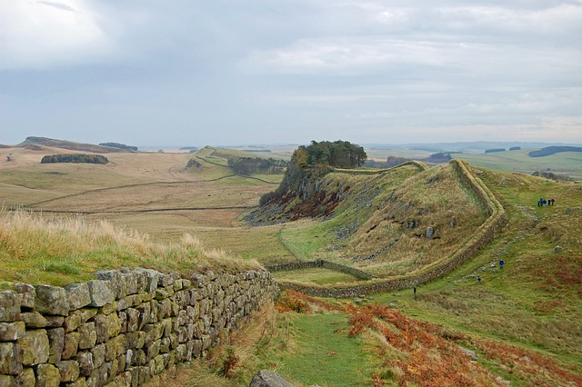
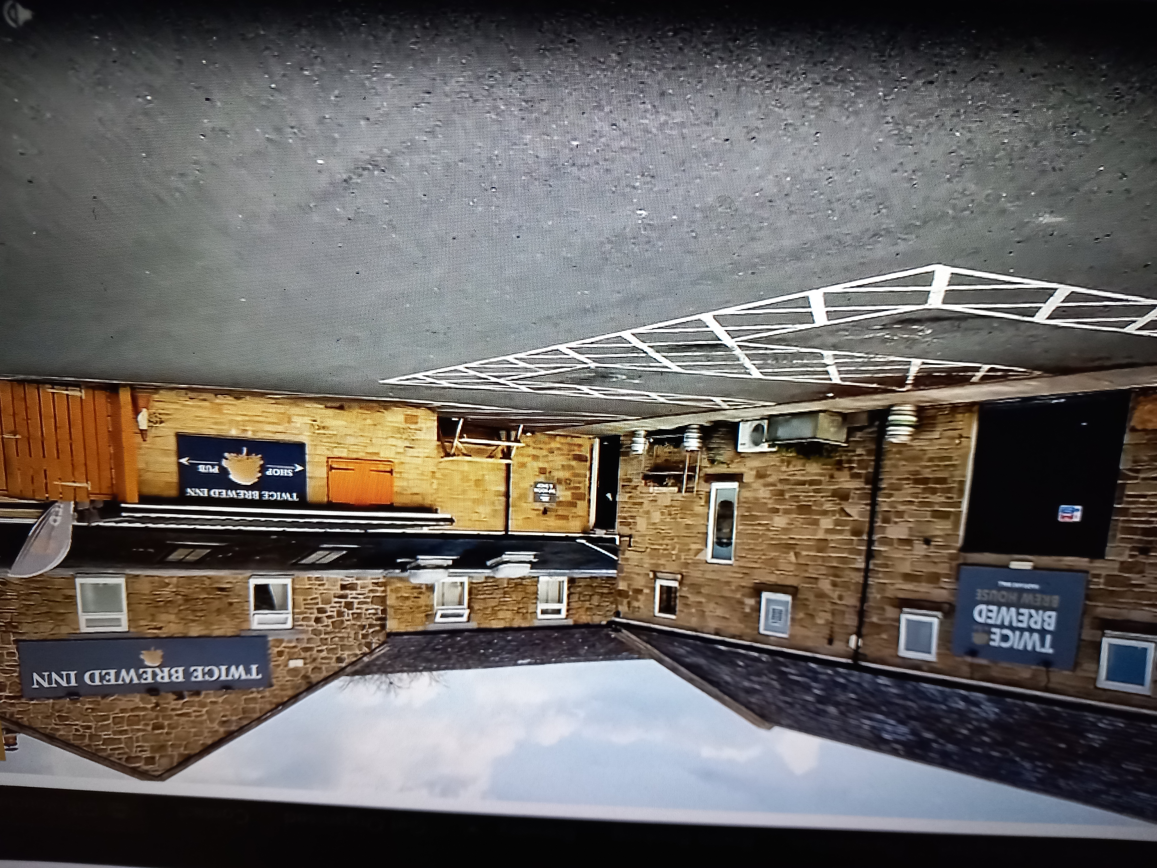
A FULL ENGLISH BREAKFAST, INCLUDING: - TEA/COFFEE/JUICES/TOAST/VEGETARIAN OPTION ETC WILL BE AVAILABLE TO ALL MEMBERS FOR THE SUBSIDISED BARGAIN PRICE OF
£7.50!!!
ALL YOU HAVE TO DO IS MAKE YOUR OWN WAY TO THE VENUE BY CAR/BUS/SCOOTER/ MOTORCYCLE OR BY FOOT –JUST GET THERE ANY WAY YOU CAN.
PAYMENT MUST BE UPFRONT (by 12 OCT) AND WILL BE NON-REFUNDABLE.

RETURN THIS SECTION ONLY
IF YOU WISH TO ATTEND PLEASE INDICATE BELOW

NAME: - ------------------------------------------------
METHOD OF PAYMENT: - BY CHEQUE:-(PAY NORTHUMBRIAN SECTION VMCC)
OR USE BANK TRANSFER: - 30-90-91 / 65688960 (NORTHUMBRIAN SECTION GENERAL ACCOUNT). PLEASE USE REFERENCE “BM” AND THEN YOUR NAME.
PLEASE RETURN THIS FORM TO: - D. HARRISON,38 PORTLAND GARDENS, EASTFIELD CHASE, CRAMLINGTON, NORTHUMBERLAND NE23 2QD, WHEN PAYING BY CHEQUE.
IF PAYING BY BANK TRANSFER JUST LET ME KNOW BY TEXT OR EMAIL.
MOB: - 07737755286
E. MAIL: - newhudson350@gmail.com

